Email Signature Banners
As of September 2025

Page 1: ACE Refresh - *NEW*
Page 2: Accumulation Whole Life
Page 3: Gateway
Page 4: Life Matters Podcast

ACE Refresh





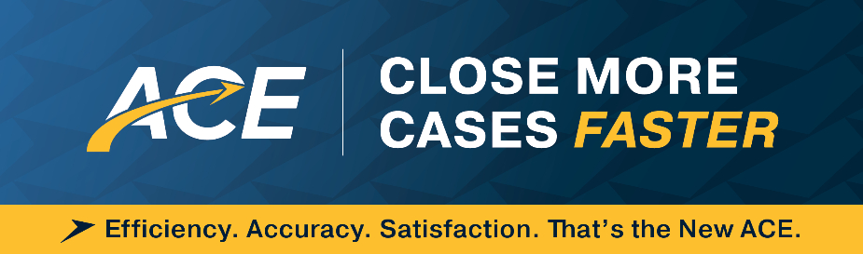



Accumulation Whole Life



Gateway




Life Matters Podcast





