Setup Instructions: Field Leader Email Signature with a Headshot
Please reference the below instructions to create your customized email signature with a headshot.

Step-by-step instructions
STEP
Add your headshot.
Right click the headshot image in the template. Select “Fill” then choose “Picture”. Navigate your computer to get the appropriate picture and click “Okay” to insert your selected image.
1
Click on your headshot image. From the Picture Tools Format menu, click on the down arrow below “Crop” and select “Fill” to auto adjust your headshot. You can click and drag your image to move it.
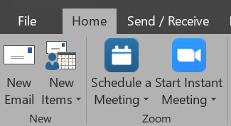
Update your contact information—add or remove based on your preferred method of contact.
Create your new Outlook email signature.
STEP
3
STEP
2
- Select “New Email” from the Home menu.

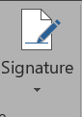
- Select “Signature” from the Message menu and
click on the dropdown arrow for “Signatures…”.

- Select “New” and enter a name for your new email
signature. Copy your completed email signature and
headshot from the template and paste it into the new
signature. Click “Okay” to save.

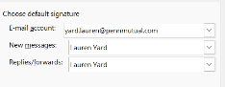
- Set your new email signature as your default signature
for new messages and replies/forwards.
41
STEP
Enjoy using your new email signature with a headshot!

Email template
Use the template below to update with your preferred contact information.
■ First and Last Name ▪ Job Title
Field Location/Agency Name
The Penn Mutual Life Insurance Company
p. xxx-xxx-xxxx
c. xxx-xxx-xxxx
e. example@email.com
w. pennmutual.com ▪ gateway.pennmutual.com

Example
Reference the example below to see how your final email signature with a headshot should look.
■ William Penn ▪ Field Marketing Director
Marketing and Communications
The Penn Mutual Life Insurance Company
c. 123-456-7890
w. pennmutual.com ▪ gateway.pennmutual.com

For questions, please contact IFNmarketing@pennmutual.com

